For Creating s3 bucket in AWS

Step 1:

Create an account in aws and login.

Step2:

Click on **services** inAWS console

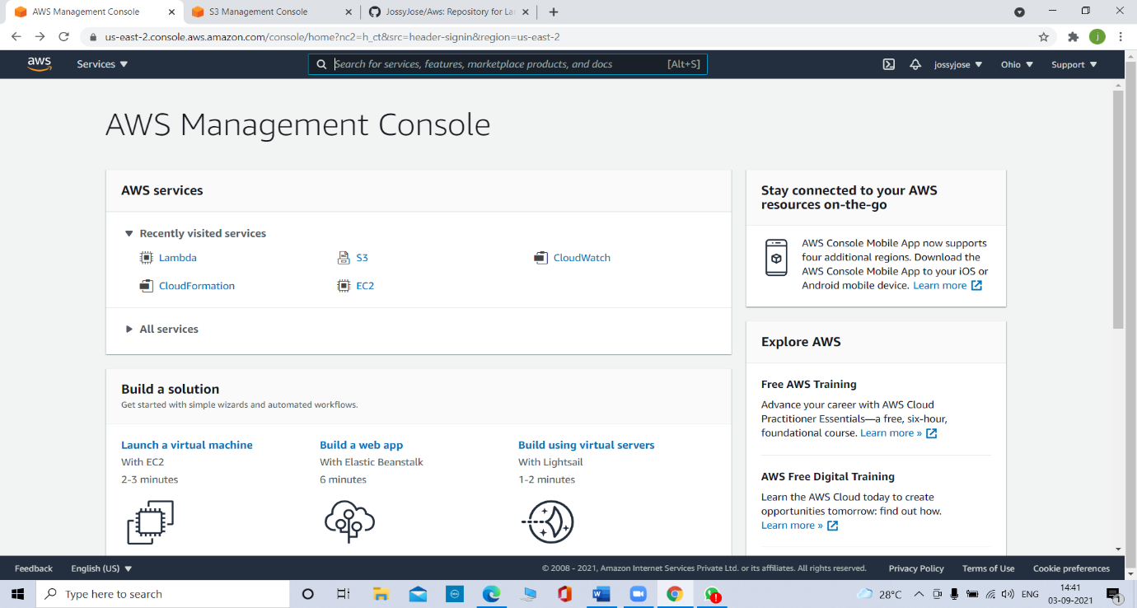

Step 3:

Click on **s3** in services

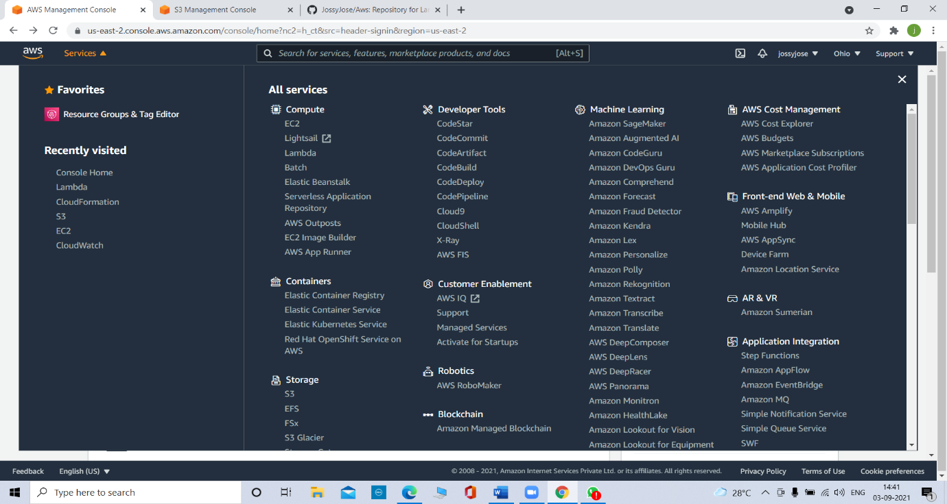

Step 4:

Click in **create bucket** button

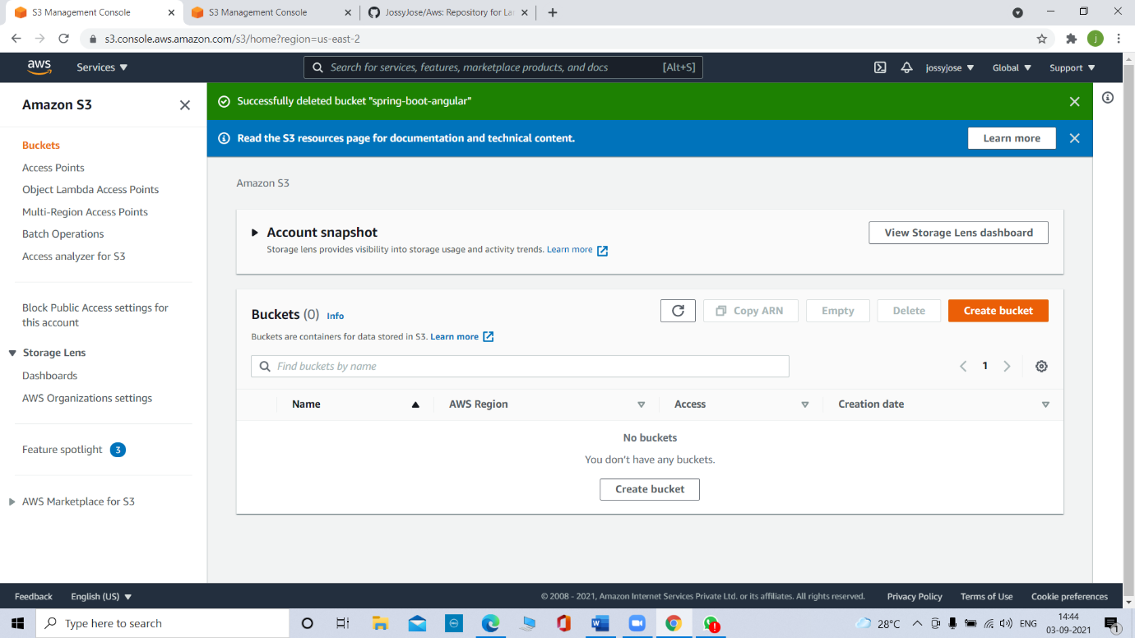

Step 5:

Fill the bucket name and click on create bucket

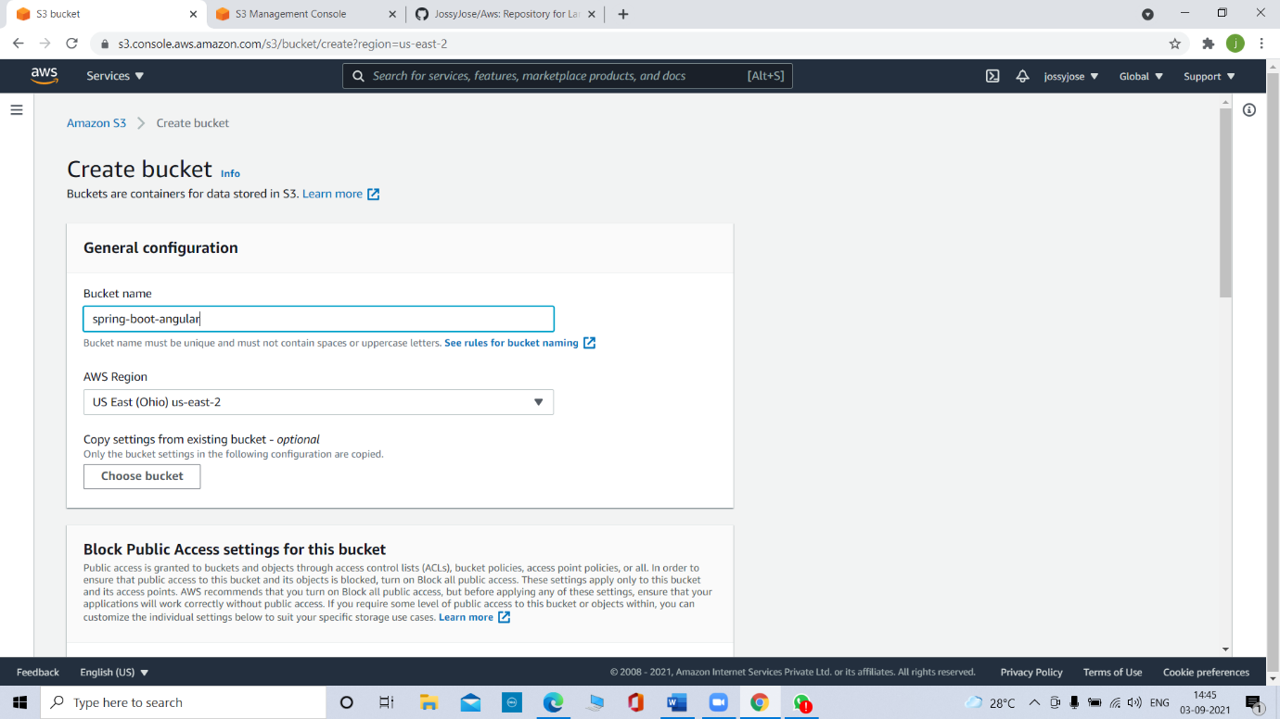

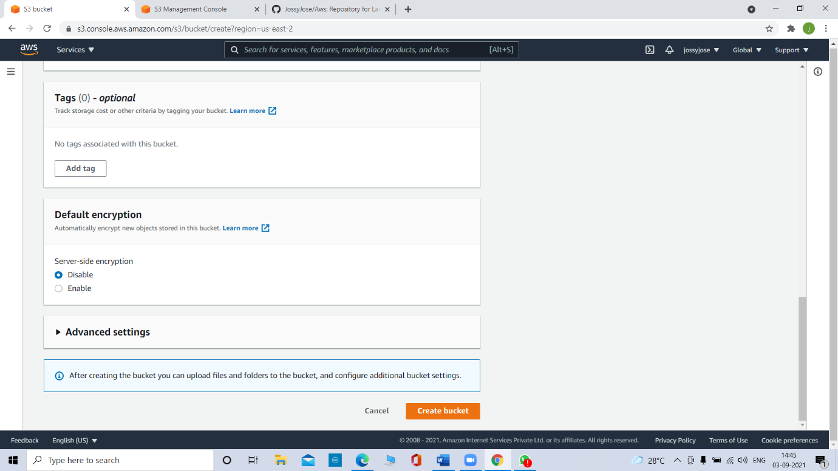

After that the bucket will create successfully.

For uploading the files into the bucket, click on the bucket name

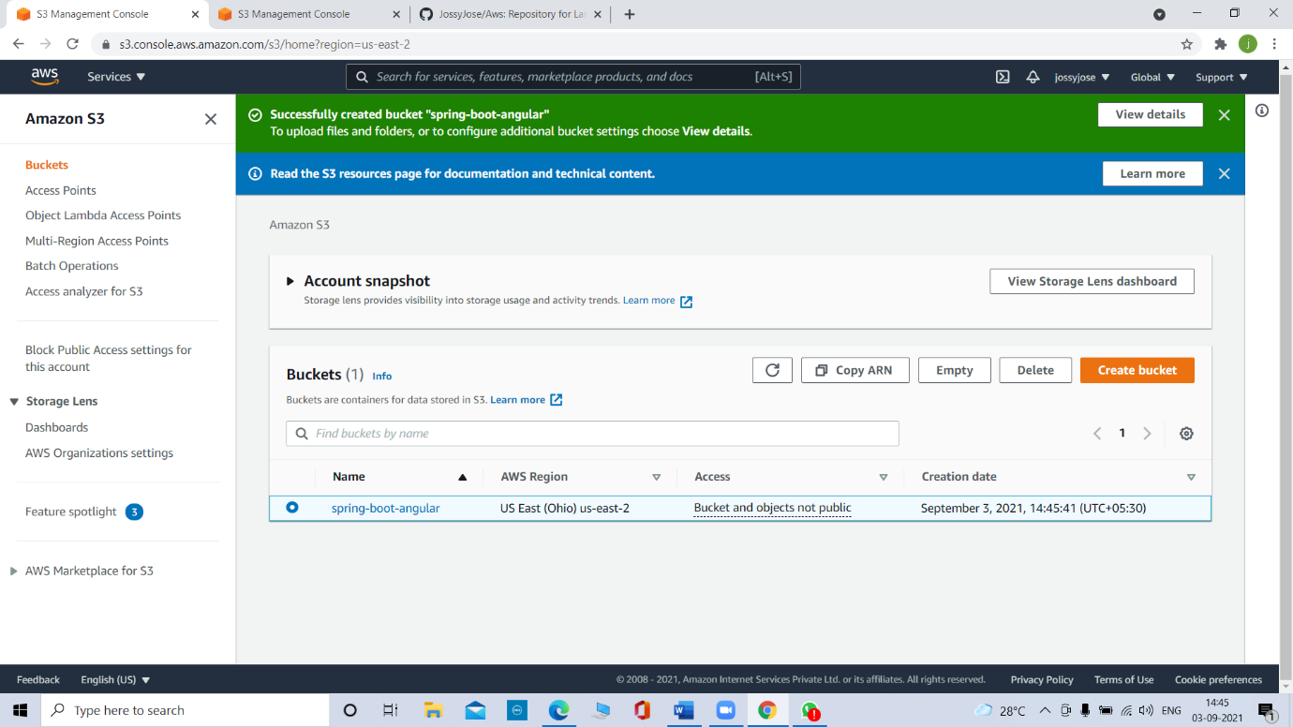

Then click on the upload button for uploading the files or folders.

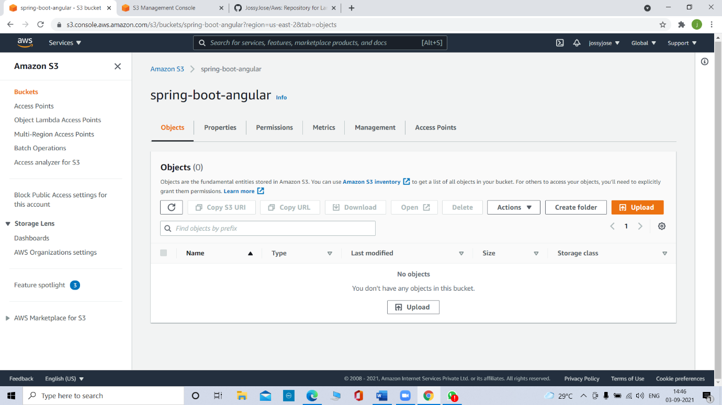

We can add files or folders into the bucket by clicking **Add files** or **Add Folders** button

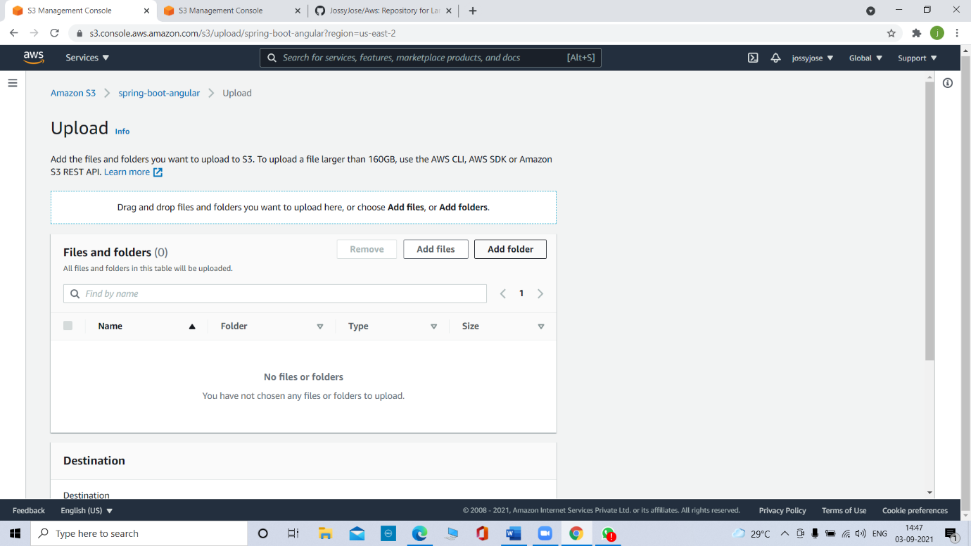

Choose or drag the files or folders, then click on **upload**

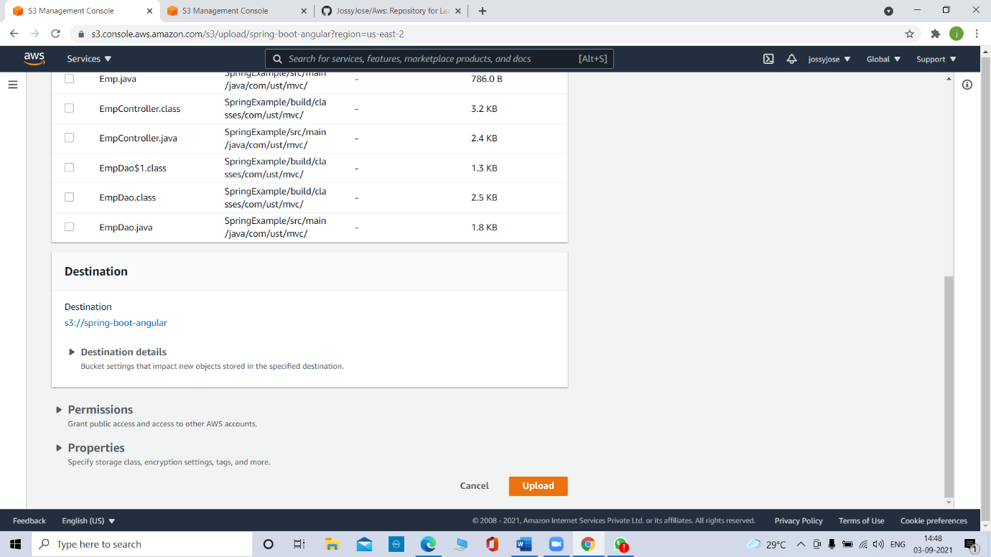

After the successful uploading we can see the file or folder in our bucket.

